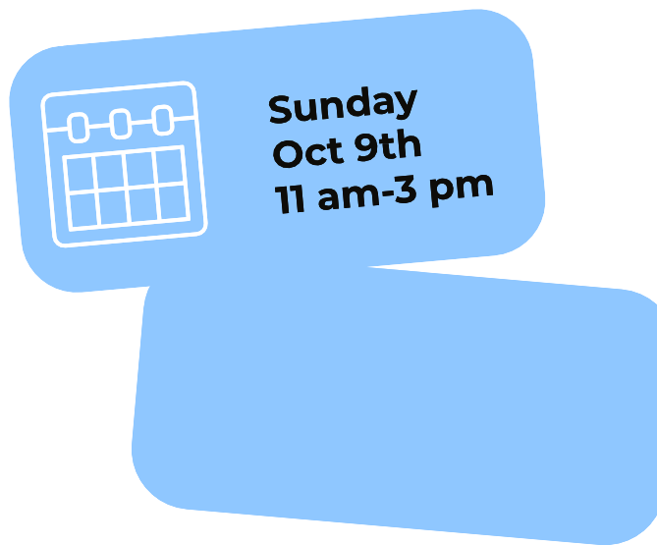
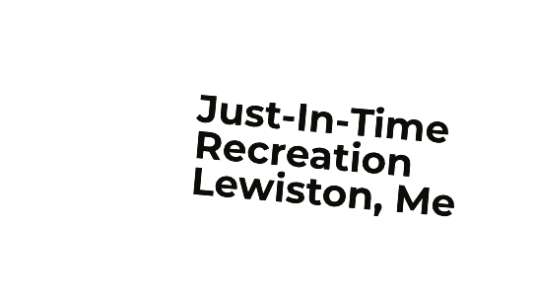
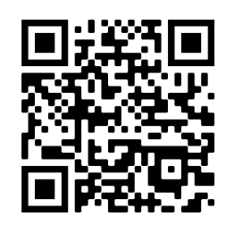
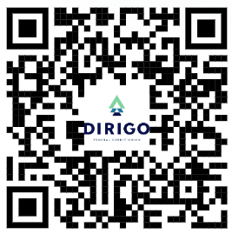

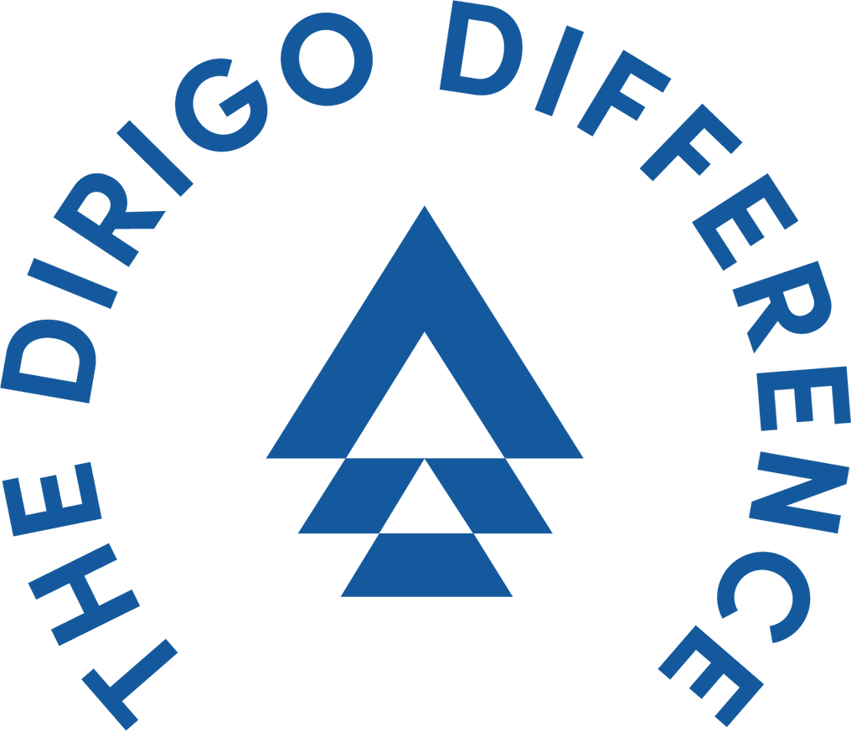
8
Sunday
Oct 8th
2023!
11am - 3 pm

(207) 786-9268
Marcellom@dirigofcu.com

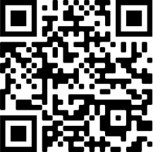
Event Sponsor $500: Premier logo placement on T-shirts, social media interview, 4-person team and lane sponsorship.

Lane Sponsor & Team $300:
Have your company’s

logo posted on a lane and have a 4 person team.

4 Person Team $200: 4 person team registration. Includes games and shoes.

Lane Sponsor $100: Have your company’s logo posted on a lane.

Donations:
Scan the QR code to make a donation. Every donation counts and 100% goes towards helping schools, nonprofits and shelters in our community
Best Team costume

21,

Marcellom@dirigofcu.com

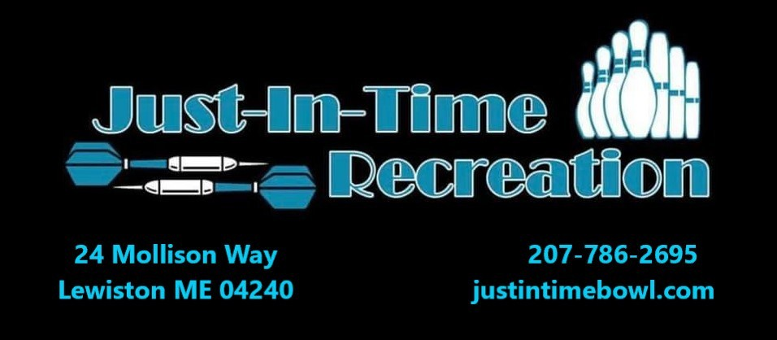
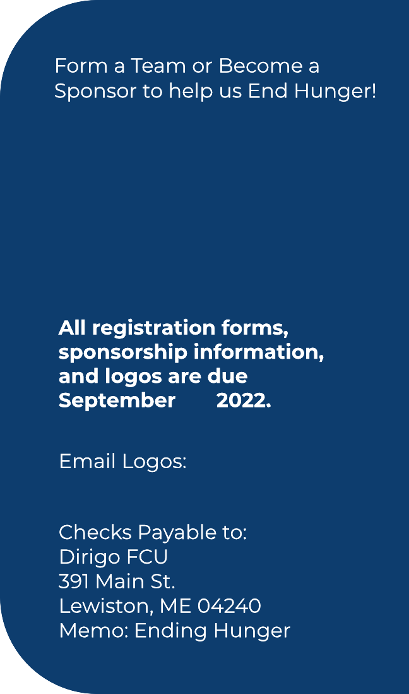
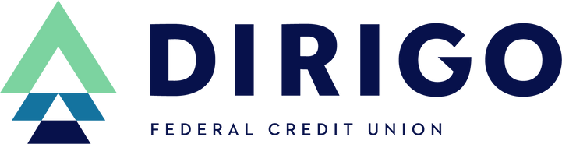

21,

